Revised Discussion

EE, 20182327

Lee Jong Geon

The main challenge in use of CISs is to increase QE and decrease x-talk to get a clear image. Uniform QE and X-talk are important about position of sensor. If we measure the QE and X-talk on the center of a chip and the side of a chip, values will be different because of a camera lens (Fig. 5). The light propagates normally to the center of a chip. However, the light propagate obliquely to the side of a chip. Therefore, QE decreases and X-talk increases with distance from the center of a chip. One solution is to shift the CIS; this change causes the light to spread smoothly to the PD region (Fig. 4). However, it until has low QE and high X-talk. To solve this problem, we simulated the tilted DTI CIS.

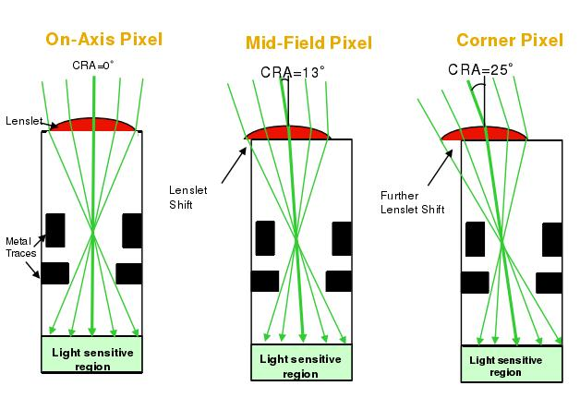

Fig. 5. Lay optics of a chip with distance from the center [1].

We increased QE 3.80 %p in red, 4.70 %p in green, 0.30 %p in blue, and 2.70 %p in white. Also we decreased X-talk 0.05 %p in red, 0.20 %p in green, and 0.10 %p in blue (Table 1). If we can more focus the light on PD region, QE will be further increased. We can use the tilted DTI CIS on the side of CMOS chip. However, the tilted DTI CIS needs more test about other effects: circuit effect (ex. dark current) and fabrication process for using this CIS structure in real product.

We decreased X-talk. However, decrements were less (<0.2%) than our goal because the transmittance of the DTI (related to spatial X-talk) and the CF (related to spectral X-talk) did not change. This law change means that the source of the X-talk didn’t change. Therefore, we should change the DTI’s material and the CF material. However, material design is not only optics work. For example, air gap is a best material to DTI. However, implement the air is almost impossible in fabrication with present technology.

The tilted DTI can’t manufacture. However, our results demonstrate that material of DTI and CF must be changed to increase QE and decrease X-talk from this result.

[1] CMOS sensor CRA https://www.dpreview.com/forums/thread/3819663 (accessed Jul 8, 2018).